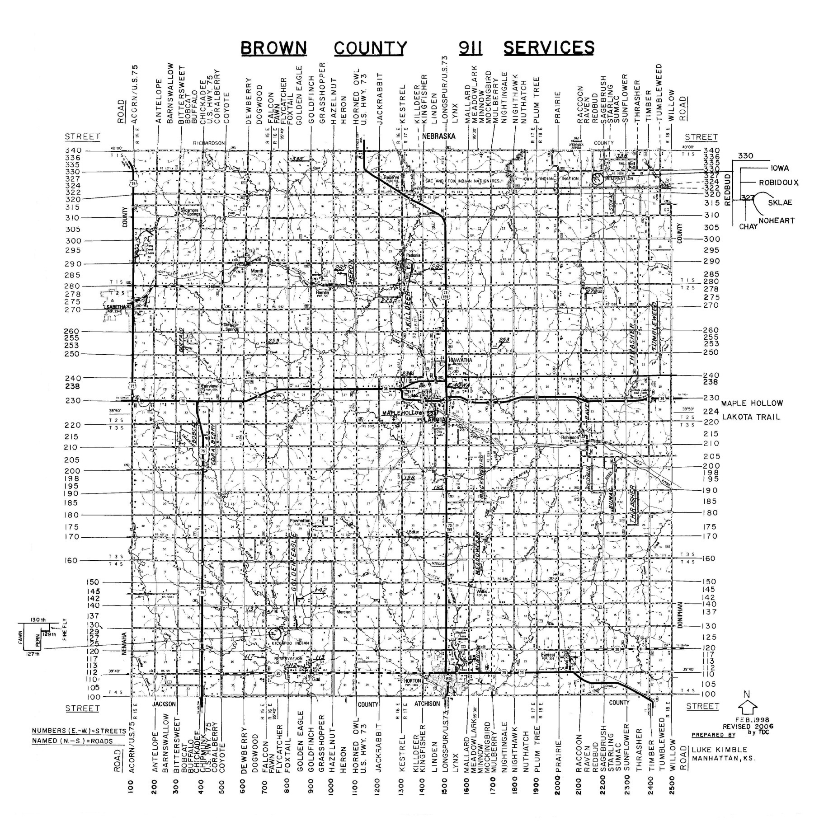

***DISTRICT #1 Richard Lehmkuhl***

***DISRICT #3 William Pollock***

***DISTRICT #2 Lamar Shoemaker***