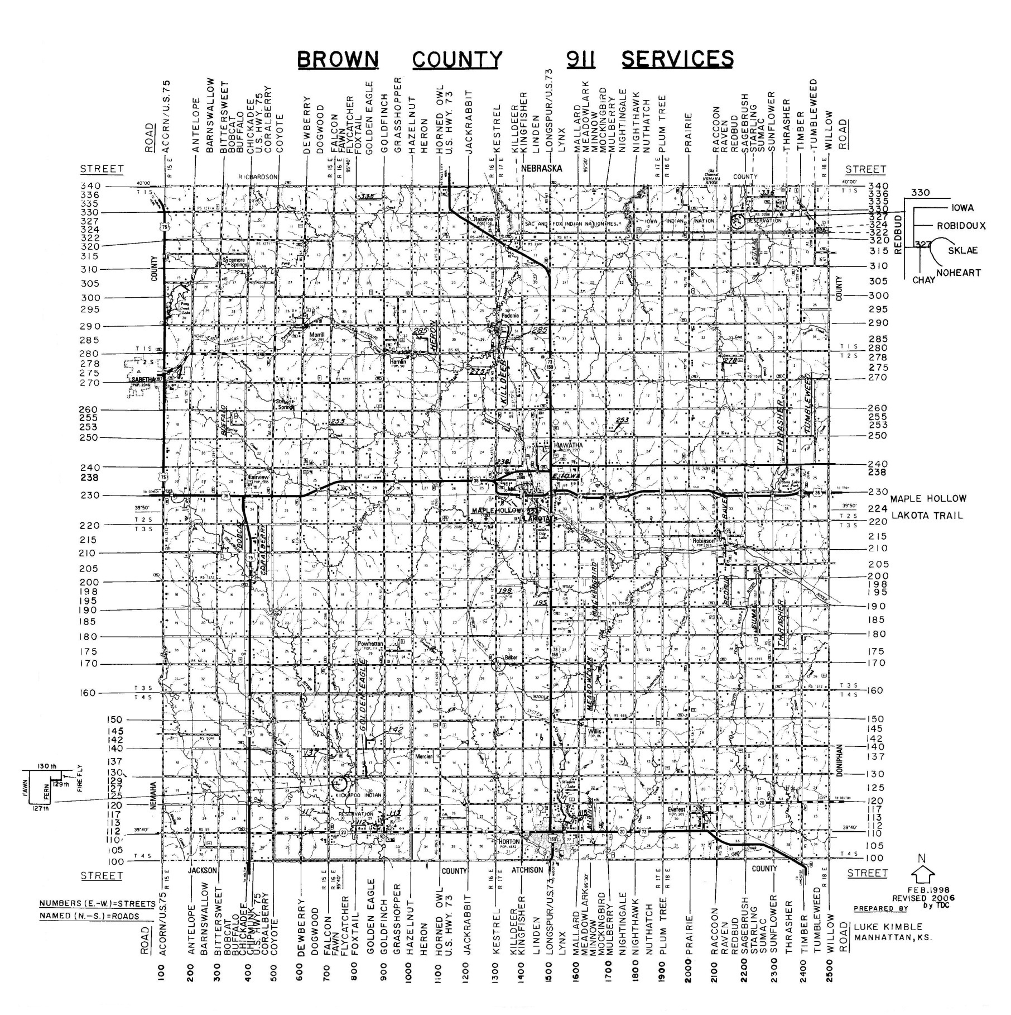

DISTRICT #1 Richard Lehmkuhl

DISRICT #3 William Pollock

DISTRICT #2 Lamar Shoemaker

